Experiment #4 – Low Pass Filter

# Youssef Samwel

# [yo800238@ucf.edu](mailto:yo800238@ucf.edu)

# EEE3352 Signal Analysis and Analog Communications

Section 0012

# Due Date 10/17/2023

# **Project Description**

The objective of this experiment is to introduce and explain the trigonometric and exponential Fourier series to the students and to understand the relationship between time waveforms and frequency spectra.

# **2.0 About Laboratory Day and Equipment List**

# The laboratory session took place on the Tuesday section between 8:00am and 11:00am on October 10, 2023. My lab partners were Joahn. The equipment for the is experiment is listed below,

1. USB Flash Drive
2. Rohde & Schwarz RTM 3034 Oscilloscope
3. Tektronix AFG3022 Function Generator
4. TL084 Operational Amplifier

# **3.0 Pre-Laboratory Preparation**

# 3.1 Filter Simulation

We will use MATLAB simulation to see the response of our filter circuits. For simulation you will need the transfer functions of both filter circuits shown in Fig. 4.20 and Fig. 4.21. The transfer functions were given earlier in this manual (See equation 4.25 and 4.26.)

In both filters and R = 1.6kΩ and C = 0.01F. For the second filter R1 = 10kΩ, R2 = 12kΩ, R3 = 10kΩ, R4 = 1.5kΩ and C = 0.01F. With the above values for resistors and capacitors the transfer functions will have the following form (notice that the coefficients are in descending order of s).

clc;

clear all;

close all;

RC = 1.6e3 * 0.01e-6;

w = 0:100:100000;

%% 1st-order Low Pass Filter

b1 = [1];

a1 = [RC, 1];

figure;

freqs(b1,a1,w);

title("1st-order Low Pass Filter");

%% 4th-order Low pass filter

b2 =  2.2*1.5;

a2 = [RC^4, 2.65*RC^3, 3.48*RC^2, 2.65*RC, 1];

figure;

freqs(b2,a2,w);

title("4st-order Low Pass Filter");

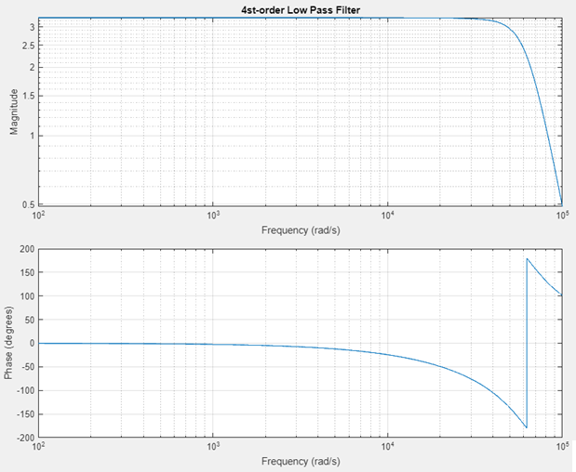

# 3.2 Pre-Laboratory Questions

1. Calculate the Trigonometric Fourier Series of a square wave with the parameters shown in Fig. 4.18 (assume it is periodic with periodic T):

The trigonometric Fourier series has the following form:

To compute the parameters of the Fourier series, it is critical to determine the period of the square wave because this will determine the fundamental frequency. The period of the square wave is determined by the repetition of after period , such that . For the periodic square wave in Fig. 4.18, the period is from to . To compute the parameters of the Fourier series we use the following equations,

Once we have the period, we can determine the fundamental frequency using this relationship, . The following is the solution for this square wave,

2. Assuming an ideal filter with a cutoff frequency of ( , show graphically, in the frequency domain, why the first harmonic of the square wave should be the only harmonic at the output.

The first fundamental frequency is determined by the relationship, , therefore if our cutoff is which is equivalent to the first fundamental frequency, the output will not contain any frequencies above the fundamental frequency. Plotting the Fourier spectrum helps show this concept visually.

Fourier Spectrum with Cut off Frequency.

3. Suppose you have an input signal with frequency components from 0 to 2 KHz. Is it possible to design a filter, which will produce an output with frequency components 4 to 6 kHz? Why or why not?

This is impossible because this is not how a filter function. A filter removes either frequency below or above a certain cut-off frequency, it does not change the frequency of the input signal.

4. What is the difference between dB/octave and dB/decade?

dB/octave is doubling of frequency whereas dB/decade is 10x of the frequency.

# **4.0 Experimental Procedure**

# 4.2 1st Order Filter

The first order filter was based on RC circuit as described below,

This first order filter is made purely of passive components and therefore the output will not have any amount of amplification. To verify this theory, we measured the input and output of the 1st order filter in the following to be 205mV and 205mV respectively. The passband gain is .

RC Low Pass in Passband Region

To determine the cut-off frequency, we measured the gain per octave above 10kHz. We started with 10kHz because the calculated cut-off frequency was 9.9kHz. The following is our oscilloscope measurements.

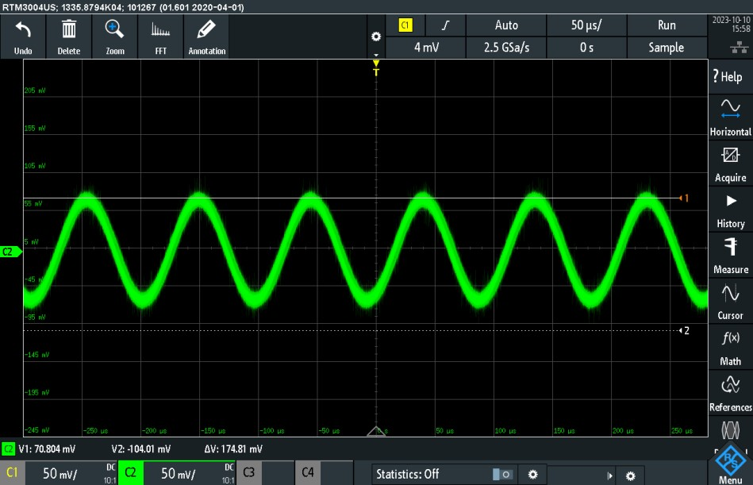

1st Order Filter Output at Cut-off Frequency

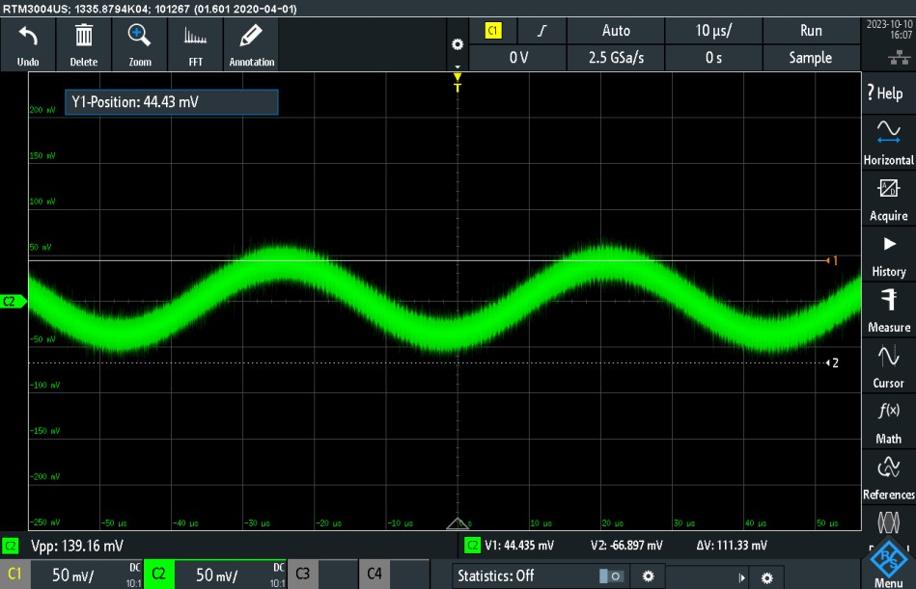

1st Order Filter Output at 22.0 kHz

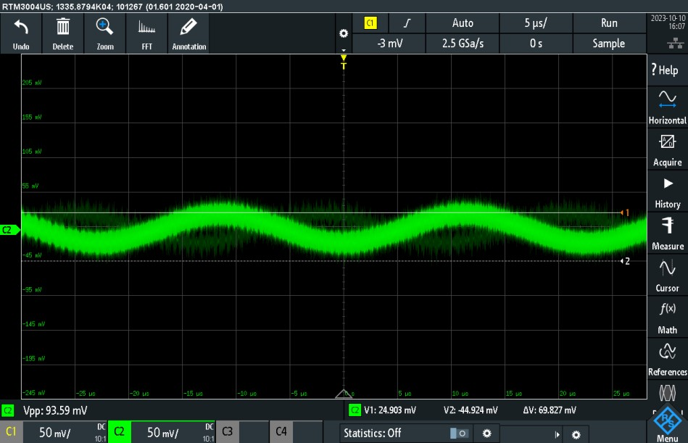

1st Order Filter Output at 44.0 kHz

|  |  |  |  |
| --- | --- | --- | --- |
| Frequency |  |  | Gain (dB) |
| 10.5 kHz | 100mV | 70.8mV | -3.00 dB |
| 22.0 kHz | 100mV | 43.5mV | -7.23 dB |
| 44.0 kHz | 100mV | 23.4mV | -12.62 dB |

The measurements clearly show that the cut off frequency of the filter is 10.5 kHz which is slightly higher than expected, this due to tolerance values on the resistor and capacitor. From this table we can compute that the rate of roll of off per octave is 5.39dB/octave.

# 4.4 1st Order Filter Square Wave Spectrum

For the 1st order filter, we also experimented with the effects of a square wave on the filter. Since a square wave is composed of many frequency harmonics, we expected to see the shape of the square wave to change because the higher frequency harmonics will be reduced.

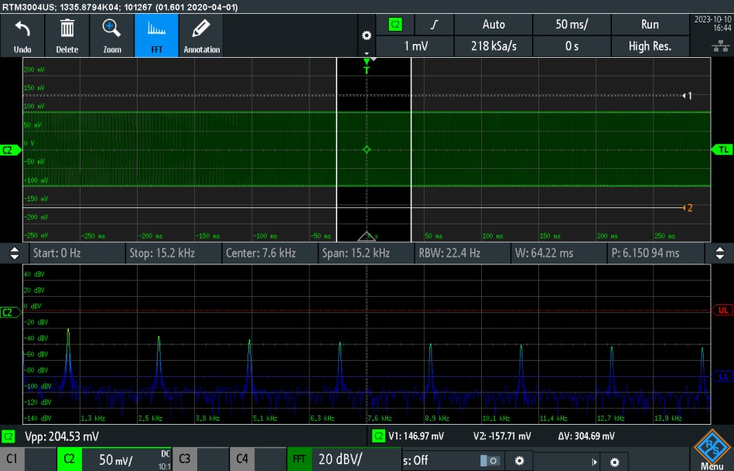

1st Order Filter Square Wave FFT Spectrum

We recorded the first 6 non-zero harmonics, the table below shows those measurements,

|  |  |
| --- | --- |
| Frequency | dBV |
| 1.0 kHz | -20.96 |
| 3.0 kHz | -30.92 |
| 5.0 kHz | -36.06 |
| 7.0 kHz | -39.82 |
| 9.0 kHz | -42.92 |
| 11.0 kHz | -45.6 |

# 4.5 1st Order Filter Integrator

We generated a square wave with 5v PP at frequency 10 times higher than our cut-off frequency of 10.5 kHz. The following screenshots shows the measurements of the input and output waveform.

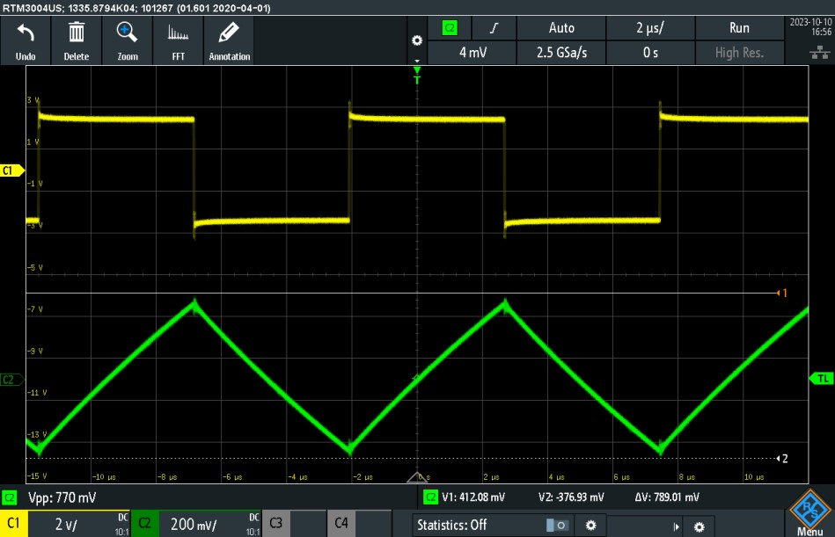

1st Order Filter Input/Output (Input: 5-V Square Wave)

4.6 4th Order Filter

In this experiment we also built a 4th Order Active Filter using the TL084 operational amplifier.

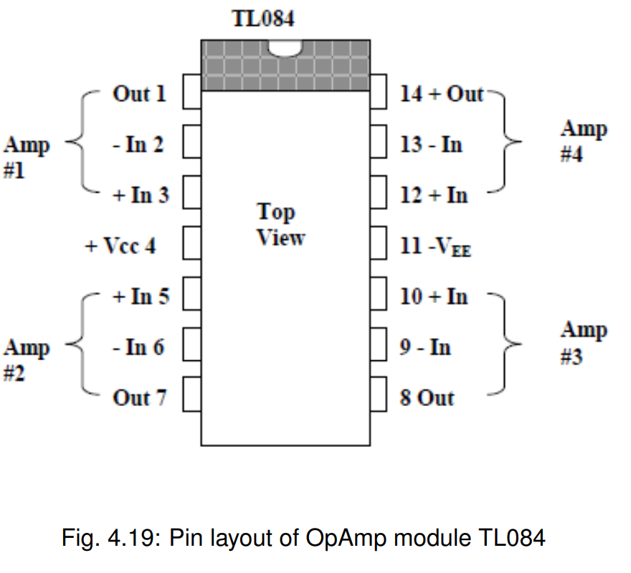

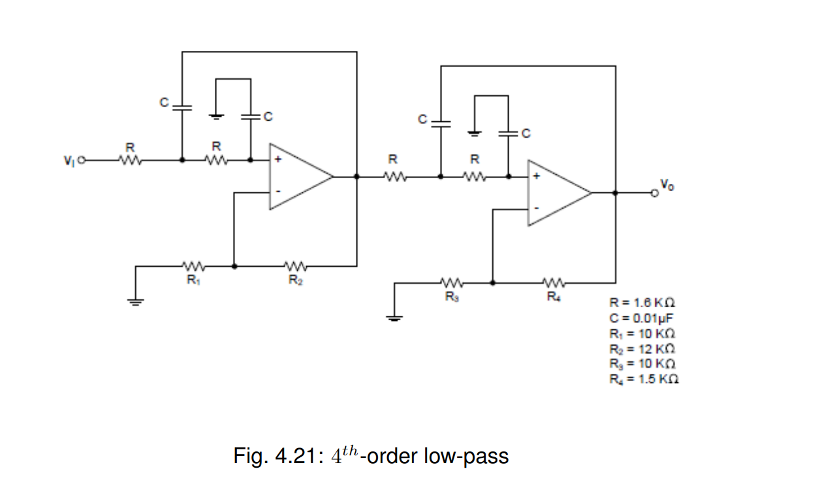

The first order is made of both passive and active components therefore this filter will have a higher passband gain and higher rate of roll-off. Unfortunately, we had issues with building this circuit. The filter was behaving outside of the designed specifications, we were unable (with the assistance of the lab TA’s) to resolve this issue within the time constrains of the lab. The circuit had the behavior of a 4th order low pass filter, however, the cut off frequency was half what it should be, and the passband gain was lower than it should be.

The following is our measurements at the cut-off frequency and two higher octave frequencies.

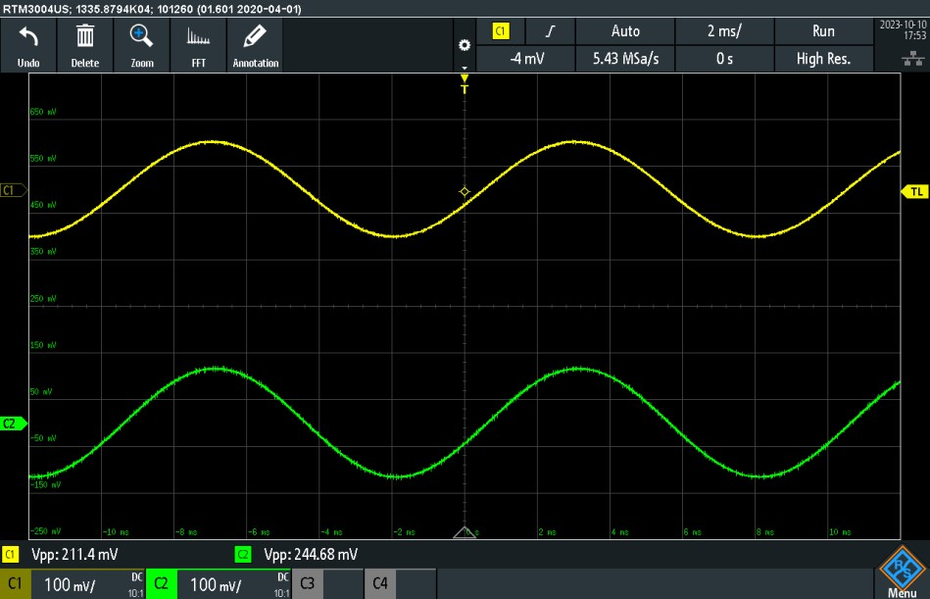

4th Order Filter Input and Output waveforms at Cut-off Frequency

|  |  |  |  |
| --- | --- | --- | --- |
| Frequency |  |  | Gain (dB) |
| 3.9 kHz | 200mV | 244.8mV | 1.754 dB |
| 7.8 kHz | 200mV | 72mV | -8.87 dB |
| 15.6 kHz | 200mV | 27mV | -17.39 dB |

The passband gain of this filter was 1.75 dB and the rate of roll off computed from the previous table is 8.52 dB/octave.

# 4.7 4th Order Filter Square Wave Spectrum

For the 4st order filter, we also experimented with the effects of a square wave on the filter. Since a square wave is composed of many frequency harmonics, we expected to see the shape of the square wave to change because the higher frequency harmonics will be reduced.

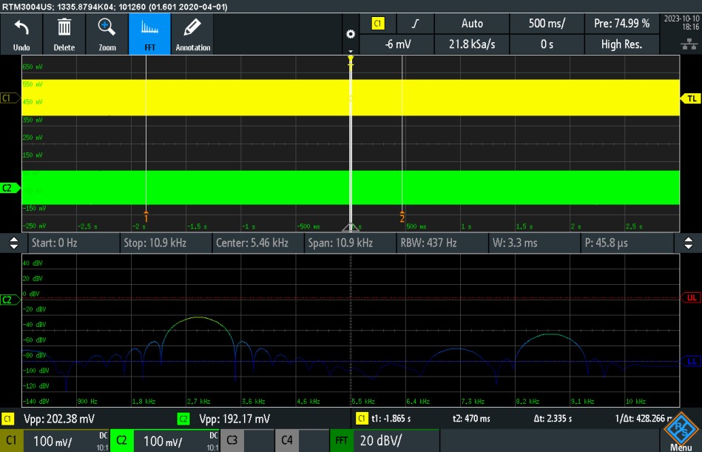

4th Order Filter Square Wave Spectrum

We recorded the first 6 non-zero harmonics, the table below shows those measurements,

|  |  |
| --- | --- |
| Frequency | dBV |
| 1.0 kHz | -20.28 |
| 3.0 kHz | -32.90 |
| 5.0 kHz | -41.00 |
| 7.0 kHz | -47.46 |
| 9.0 kHz | -53.20 |
| 11.0 kHz | -58.50 |

# 4.9 Calculations and Questions

1.Convert the values you measured for the square wave in Section 4.5.4 in dBV to volts and compare to your Fourier Series Coefficients calculated in the Prelab. Recall that the measured amplitudes are RMS amplitudes, so the values must be multiplied by the square root of 2. 2. Compare the expected results for filter gain and filter roll off rate to your measured results.

For the first order voltages are: 0.126623699, 0.040226755, 0.022259479, 0.014438265, 0.010104504, 0.007421898.

For the fourth order voltages are: 0.136935168, 0.032026907, 0.012604192, 0.005991216, 0.003093962, 0.001680796

The rate of roll off is higher for the 4th order filter, and the harmonics coefficient match the pattern formed by Fourier series.

# **5.0 Learned Objectives**

* Understanding the Basics of Low Pass Filters
* Practical Application of Fourier Series
* Analysis of Filter Behavior
* Problem-Solving and Troubleshooting

# **6.0 Conclusion**

In this experiment, we explored low-pass filters, Fourier series, and signal analysis in practical applications. We aimed to understand the fundamental concepts and their real-world significance. Our lab equipment, including the oscilloscope and function generator, allowed us to conduct experiments and gather valuable data. We conducted MATLAB simulations to investigate filter circuit responses, focusing on two filter designs with different components. The trigonometric Fourier series played a central role in our analysis, aiding us in calculating coefficients for a square wave signal. We also discussed ideal filters, emphasizing that they remove frequencies beyond a specific cutoff rather than changing input frequency. Through our experimental procedure, we gained insights into 1st and 4th-order filter behavior. While the 1st order filter performed as expected, the 4th order filter faced practical challenges. In, summary, this experiment helped us connect theory to practice, enhancing our understanding of low pass filters, Fourier series, and signal processing. It also highlighted the importance of practical considerations in electronics applications. Our knowledge and skills have grown, preparing us for future work in this field.